HALLOWEEN CRAFT

Friday October 19, 2018

Drop in between 1 pm and 4 pm

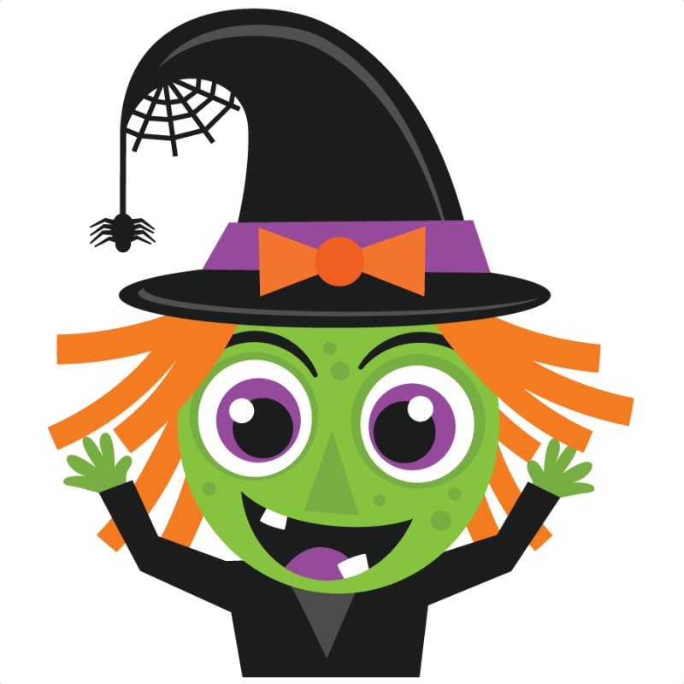

All Ages Welcome

Armada Free Public Library
73930 Church Street
Armada, Mi

